Snap 2012 Mock Test Paper
Directions for next eight questions: Each question has a pair of capitalized words followed by four pairs of words. Choose the pair of words which best expresses the relationship similar to that expressed in the capitalized pair.
VERSE : POETRY
Plot : Novel
Lyrics : Song
Refrain : Chorus
Excerpt : Article
BARREL : CONTAINER
Box : Carton
Files : Cabinet
Ashes : Urn
Penthouse : Apartment
SOOTHE : AGGRAVATE
Fear : Awe
Save : Squander
Criticise : Acquit
Perplex : Please
WOOD : PAPER
Dye : Colour
Lead : Pencil
Sand : Glass
Jewellery : Gold
STONE : SCULPTOR
Canvas : Painter
Paper : Writer
Wire : Electrician
Carpenter : Wood
ABSOLVE : EXONERATE
assauge : mollify
countermand : flout
indefatigable : tiring
parapet : roof
STAR : CONSTELLATION
planet : cosmos
subject : literature
string : violin
island : archipelago
DOE : BUCK
fox : jackal
tiger : cat
ewe : ram
vixen : witch
Directions for next two questions: The first and the second word share a relationship. Find the word that shares a similar relationship with the third word.
Labourer : Wages : : Entrepreneur : ___
Business
Profit
Debt
None
Pulchritude : Repulsiveness : : Fortitude : ____
Detachment
Loneliness
Pusillanimity
Depravity
Directions for next five questions: Read the short passages carefully, and then answer the question that follows each.
The society which, by fixing itself in place locally, gives space a content by arranging individualised places, thus finds itself enclosed inside this localisation.
This is equivalent to:
Racing, with its preoccupation on speed is a sport that survives in spite of close encounters with death.
Women’s magazines, with emphasis on beauty, sexuality and independence are actually fixated on capitalism since they are by-products of consumerism.
Psychiatrists maintain that reading habits when begun early create a whole world of imagination in a child’s mind that is of great developmental importance.
The paraphernalia of the armed forces are merely a semiotic of aggression and antagonistic war dances.
To understand the origins of the word ‘classic’, we need to return to the ancient Greeks, who by peculiar good fortune and natural enlightenment of mind, had no classics but themselves. They were at first the only classical authors for the Romans, coming just after, who strove and contrived to imitate them.
Which of the following if true would strengthen the argument of this passage?
At first the only true classics were the ancient Greeks.
The Greeks were in a class by themselves.
The Greeks were revered by the Romans who had a love of Greek art.
The Greeks and Romans together laid foundations for classical art.
Self-consciousness exists in itself and for itself, in that, and by the fact that it exists for another self-consciousness; that is to say, it ‘is’ only by being acknowledged or “recognised.”
This statement is equivalent to:
Tobacco companies spend increasingly on point-of-purchase merchandise since the consumer is most vulnerable at the moment of choice.
Offices increasingly have reflective glass in their lobbies since anti-social behaviour is reduced when people are continually aware of how they appear.
Video cameras are installed in most shopping malls in order for the store to monitor the goings-on not just among customers but also among staff.
To become a hit playback singer it is necessary to be recognised as the number one in a particular genre of music.
A true classic, as I should like to hear it defined, is an author who has enriched the human mind, who has spoken to all in his own peculiar style, a style which is found to be also that of the whole world, a style new without neologism, new and old, easily contemporary with all time.
We can infer that:
A classic, according to the usual definition, is an old author canonised by admiration, and an authority in his particular style.
A classic may for a moment have been revolutionary; it may at least have seemed so, but it is simply a subversion of whatever prevented the restoration of the balance of order and beauty.
A classic refers to those who have become models in any language whatever, have established the expressions, models, fixed rules for composition and style, strict rules of art to which men must conform.
A classical author is one who has discovered some moral and not equivocal truth, or revealed some eternal passion or desire.
In the historical society divided into classes, culture is the general sphere of knowledge and of representations of the lived; which is to say that culture is the power of generalisation existing apart, as division of intellectual labour and as intellectual labour of division.
From the passage above, culture is clearly:
A means of segregating the classes
A natural product of a historical society
A factor of the intellect
A generalised means of historicising society
Directions for next five questions: Each question has a pair of capitalized words followed by four pairs of words. Choose the pair of words which best expresses the relationship similar to that expressed in the capitalized pair.
CARVE : WOOD
Create : Origin
Sculpt : Marble
Model : Medium
Origami : Paper
LESSON : LEARN
Difficult : Child
Skill : Master
Mango : Ripen
Pleasure : Undergo
SENTENCE : COPULA
Chain : Link
Alphabet : Letter
Word : Syllable
Conviction : Crime
BRIDGE : GAP
Fill : Void
Air : Vacuum
Free : Bird
Rule : Abolish
REPUTATION : TARNISH
Competition : Ruin
Character : Defame
Standing : Drop
Virtue : Scandal
Directions for next five questions: Each sentence has a blank. From the alternatives given, choose the appropriate one to fill the blank.
I ____ you at our wedding.
look forward to see
I am looking forward to see
look forward to seeing
am looking forward to seeing
It was really astonishing that she ___ to talk to you.
was refusing
is refusing
had refused
refuse
During the initial ____ years, nutritionally adequate food has to be given to the child, because any damage done initially cannot be repaired afterwards.
tender
impressionable
formative
early
There is no point doing anything about it, ____?
isn’t it
is it
is there
doesn’t it
From its ____ origins in the rural areas of the country Kabaddi is gradually going international.
vague
uncertain
humble
small.
Directions for next six questions: Refer to the passage below and answer the questions that follow.
PASSAGE – 1
The Battle of Hastings was the first major Norman victory in the Norman conquest of England in 1066 A.D. On September 28, 1066, William of Normandy, bent on asserting by arms his right to the English crown, landed unopposed at Pevensey. On hearing the news, the Saxon King Harold, who had just destroyed the Norwegian Viking army under King Harold Hardrade at the Battle of Stamford Bridge in Yorkshire, hurried southward, gathering what forces he could on the way. He took up his position, athwart the road from Hastings to London, on Senlac Hill some six miles inland from Hastings, with his back to the great forest of Anderida (the Weald) and in front of him a long glacis-like slope, at the bottom of which began the opposing slope of Telham Hill. The town called Battle in the modern county of East Sussex was named to commemorate this event.
The English army was composed almost entirely of infantry, and had just been through two forced marches and a battle. The shire levies, for the most part destitute of body armour and with miscellaneous and even improvised weapons, were arranged on either flank of Harold’s guards (huscarles), picked men armed principally with the Danish axe and shield.
Before this position Duke William appeared on the morning of October 14. His host, composed not only of his Norman vassals but of barons, knights and adventurers from all quarters, was arranged in a centre and two wings, each corps having its archers and arbiasters in the front line, the rest of the infantry in the second and the heavy armoured cavalry in the third. Neither the arrows nor the charge of the second line of footmen, who, unlike the English, wore defensive mail, made any impression on the English standing in a serried mass behind their interlocked shields. Then the heavy cavalry came on, led by the duke and his brother Odo, and encouraged by the example of the minstrel Taillefer, who rode forward, tossing and catching his sword, into the midst of the English line before he was pulled down and killed. All along the front the cavalry came to close quarters with the defenders, but the long powerful Danish axes were as formidable as the halbert and the bill proved to be in battles of later centuries, and they lopped off the arms of the assailants and cut down their horses.
The fire of the attack died out and the left wing (Bretons) fled in rout. But as the levies broke out of the line and pursued the Bretons down the hill in a wild, formless mob, William’s cavalry swung round and destroyed them, and this suggested to the duke to repeat deliberately what the Bretons had done from fear. Another advance, followed by a feigned retreat, drew down a second large body of the English from the crest, and these in turn, once in the open, were ridden over and slaughtered by the men-at-arms.
Lastly, these two disasters having weakened the defenders both materially and morally, William subjected the huscarles, who had stood fast when the fyrd broke its ranks, to a constant rain of arrows, varied from time to time by cavalry charges. The huscarles endured the trial for many hours, from noon till close on nightfall; but at last, when the Norman archers raised their bows so as to pitch the arrows at a steep angle of descent in the midst of the huscarles, the strain became too great. While some rushed forward alone or in twos and threes to die in the midst of the enemy, the remainder stood fast, too closely crowded almost for the wounded to drop. At last Harold received a mortal wound, supposedly pierced through the eye by an arrow. The English began to waver, and the knights forced their way in. Only a remnant of the defenders made its way back to the forest; and William, after resting for a night on the hardly-won ground, began the work of the Norman Conquest.
Battle Abbey was built at the site of the battle, and a plaque marks the place where Harold fell.
Who was Harold?
the king of Norway
the king of England
the king of Saxony
the Duke of Normandy
What does the word “athwart” as used in the passage mean?
parallel to
next to
across
near
Which of the following statements is the only one that can be inferred from the information given in the passage?
The Bretons were on the side of the English.
The Battle of Hastings took place near Stamford bridge in Yorkshire.
The Danish fought alongside the English in the Battle of Hastings.
The Normans had been mediocre in battle prior to the battle of Hastings.
Which of the following was not weapon/weapons used during the Battle of Hastings?
sword
bow and arrow
axe
halbert
Which of the following statement is justified by the passage?
I. The Normans were better prepared for battle than the English during the Battle of Hastings.
II. It is not known for certain how Harold died.
III. The Battle of Hastings lasted for several days.
only II
only III
both I and II
both II and III
Which of the following best describes the style of the passage?
narrative
descriptive
analytical
discursive
irections for next five questions: Each question has a jumbled sentence, Rearrange the phrases so as to form a grammatical and meaningful sentence.
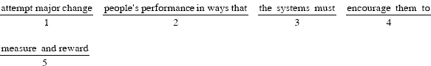
35241
35214
41253
34152
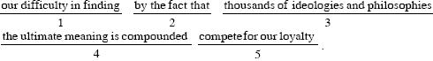
42135
13524
14235
42315
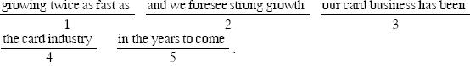
45123
31425
54132
21453
24351
15324
12435
14352
15432
21543
25134
31542
Directions for next four questions: Select the option whch correctly replaces the underlined part.
Although the early glimmerings of modern behaviour that are appearing far from Europe, that continent still contains the best record of how the Ice Age mind was evolving.
In spite the
Despite the
Apart from
Despite of the
The current food supply would not last barely a month if it is not replenished at regular intervals.
could not last hardly a month if it is
would not last a month if it will be
will last barely a month if
will not last a month if it would be
Although in many places the water hyacinth is considered as a noxious weed, they are deliberately cultivated in West Bengal for pig and cattle feed.
to be a noxious weed, they are
noxious a weed, they are
a noxious weed, it is
noxious weed, it is

John, accompanied by his brother and uncle, are scheduled to arrive in Kolkata today.
with his brother and uncle, are scheduled to arrive
and his brother and uncle, is scheduled to arrive
accompanied by his brother and uncle, is scheduled arrival
accompanied by his brother and uncle, is scheduled to arrive
Directions for next four questions: Choose the correct alternative.
Which of the following number has maximum factors?
36
76
82
191
There are 7 men, 6 women and 3 children. A committee of 6 people is to be formed such that it consists of exactly one child and two women. In how many ways can this be done?
175
2175
571
1575
73% people take atleast one drink of tea, coffee, milk. 52% take tea, 38% take coffee, 10% take milk and 7% take all three. How many people take atleast two drinks?
20%
23%
34%
25%
55% people like to travel by bus, 37% people like to travel by auto and 25% people like to travel by taxi. Also, 30% people like to travel by atleast two vehicles from bus, taxi and auto, while 6% people like to travel by all the three, then how many people like to travel by atleast one of the three vehicles?
94%
93%
87%
81%
Directions for next two questions: Refer to the data below and answer the questions that follow.
A survey of a class of students revealed that one-fifth of the class comes to college by private vehicle, one-sixth travels by public transport and one-seventh of those who travel by public trasport do not travel by private vehicles.
What fraction of the students travel by either a private vehicle or public transport or both?
Cannot be determined
In how many ways can 3 Sovereigns be given away, when there are 4 applicants and any applicant may have either 0, 1, 2 or 3 Sovereigns?
18
16
19
20
Train X starts at 6:00 a.m. from a certain station with P kmph and train Y starts at 8:30 a.m. from the same station at Q kmph. If Q > P, then how many hours will train Y take to overtake train X?
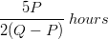
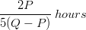
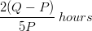
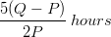
There are 190 chairs, they are to be arranged in rectangular manner. Initially, when the chairs are arranged 5 more chairs are needed. When number of rows is increased by 2, 35 more chairs are needed, then how many rows were there initially?
17
13
15
None of these
Find the sum of all numbers divisible by 3 between 1 to 180, excluding 180.
541
177
58
531
The area of the ACE enclosed in a regular hexagon of side 3 cm is:
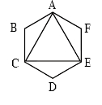
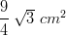
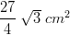
None of these
n the figure below, the circle is inscribed in a square. If the square has side of length 100 cm, then the perimeter of the square is approximately how much greater than the circumference of the circle?
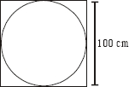
96 cm.
21 cm.
243 cm.
86 cm.
A container filled with milk holds 20 litres. 4 litres of milk is removed and replaced with water. Then 8 litres of the solution is replaced with water. Then 16 litres removed and replaced with water. Find the ratio of milk to water.
Five students and three teachers can stand in a line so that no two teachers are together in
14400 ways
720 ways
7200 ways
28800 ways
In a group of 20 people, there are 8 males and 6 married people, find the number of unmarried females, if the ratio of married male to married females is 1 : 2.
2
4
8
16
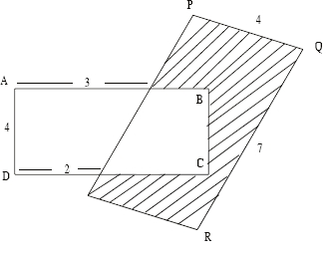
In the figure, two rectangular regions overlap. If the area of is 20, what is the perimeter of the shaded region?
A person standing on a road observes the vehicles passing by. What is the probability that the numbers of the vehicle’s number plate will have the first two digits same?
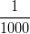
None of these
In the XY plane, which of the following points is farthest from the origin?
(0, 3)
(1, 3)
(2, 1)
(2, 3)
By weight, liquid A makes up 7% of solution I and 14.5 % of solution II. If 3 grams of solution I is mixed with 2 grams of solution II, then liquid A accounts for what percent of the weight of the resulting solution?
6.09%
10%
10.75%
21.5%
If f(x) = + 2bx + 3, f(1) = 15, f(3) = 51. Find ‘a’.
6
4
10
2
Ramlal divides 35000 among his 3 sons such that if Rs 1500, Rs 2500 and Rs 3000 were reduced from each share the amounts with them would be in the ratio of 3 : 5 : 7 respectively. Find the share of each son.
7100, 11833, 16066.67
7000, 12000, 16000
7200, 10833.33, 16966.67
7100, 10833.33, 17066.67
Mary used th of her monthly salary for car payment and th more than the amount of car payment for the rent. What fraction of her monthly salary did Mary use that month for the car payment and rent combined?
Sister’s age is 3 times that of her brother’s. After 5 years the sister shall be twice as old as her brother. How many years before, the sister’s age was 6 times of her brother’s age?
1 year
3 years
5 years
10 years
A car travelled 80 km at 16 kmph. What should be its average speed for next 4 hours so that the total average speed becomes 14 kmph?
15 kmph
11.5 kmph
15.4 kmph
12 kmph
The rectangular rug shown in the figure below has a floral border 1 foot wide on all sides. What is the area, in square feet, of that portion of the rug that excludes the border?
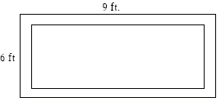
28 sq. ft
40 sq. ft
45 sq. ft
48 sq. ft
(x) = – 13x + 40 and
g(x) = – 3x – 18
for which values of x; f(x) < 0 and g(x) < 0
-3 < x < 8
-3 < x < 6
5 < x < 6
5 < x < 8
Which of the following cannot be the area of the figure?
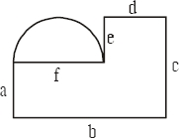
ab + de + 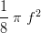
af + dc +
af + ad + de + 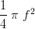
None of these
What is the radius of a largest sphere that can be kept inside a cuboid with square base, of height 7 cm and 126 cc. volume?
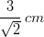
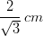
A sequence is such that the difference between successive terms form an Arithmetic Progression than its term is given by.
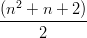
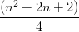
n(n – 1)
All of these
A coin is biased in such a way that probability of getting heads in any toss is . What is the probability of getting tails for two consecutive tosses?
8
9
10
12
To buy RAM chips a computer hardware dealer travels from Mumbai to Daman. The chips are 10% cheaper in Daman. He buys 25 chips. Expenses for this trip are Rs. 300, if overall he saves Rs. 2200 find the cost of one chip in Daman.
Rs.800
Rs.900
Rs.1000
Rs.1100
A person with some money sepnds on clothes, of the remaining on food and of the remaining on travel. He is left with Rs.100. How much did he have with him in the beginning?
Rs.150
Rs.200
Rs.250
Rs.300
A manufacturer of a Gate Valve sells valves for 20% profit to an end user. The end user after usage for 2 years puts it for reservicing. Incurs expenses of Rs.400 for these and then manages to sell the same to a wholesaler for a profit of Rs.500. The wholesaler sells it to a consultant for Rs.2700. During the last transaction no profit no loss occured. Find the change in price in percentage throughout the sequence.
20%
30%
33.33%
80%
Directions for next two questions: From the two quantities I and II,
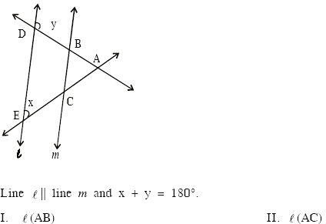
if quantity in I is greater than that in II.
if quantity in I is smaller than that in II.
if quantity in I is equal to that in II.
if quantity in I is greater than or equal to that in II.
There are 3 white and 2 red balls in a box. Three balls are taken out of the box.
I. Probability that atleast 2 are red.
II. Probability that atmost 2 are white.
if quantity in I is greater than that in II.
if quantity in I is smaller than that in II.
if quantity in I is equal to that in II.
if quantity in I is greater than or equal to that in II.
Directions for next four questions: Refer to the date below and answer the questions that follow.
‘a + b’ means ‘a x b’
‘a – b’ means ‘a b’
‘a x b’ means ‘a + b’
‘a b’ means ‘a – b’
Calculate 12 + {34 × 14 + [20 10 – 5]}.
2088
2134
3456
None of these
A certain fraction is such with integral and denominator that if the numerator is multiplied by 3 and 1 is added to the denominator, the fraction equals 1. If the numerator is squared and 10 is added to the denominator, the fraction equals . What is the fraction?
y is inversely proportional to xy = 40, when x = 25, find the value of y, when x = 10.
100
25
50
75
, then x is equal to:
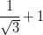
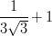
Directions for next seven questions: Refer to the line graph below and answer the questions that follow.
The following graph shows the sale of four top brands of biscuits in the market and their sale in million rupees.
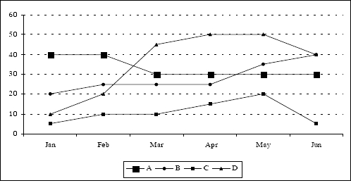
In which month was the percentage increase in market value for any biscuit recorded the greatest?
March
February
May
April
Which brand of biscuits showed the greatest percentage decrease in market value for any month?
B
D
C
A
Which month showed the highest average biscuits sales?
March
April
May
June
The cost of D biscuits was increased from Rs.10 to Rs.12 from 1st of April. And the cost of A biscuits was reduced from Rs.15 to Rs.9 from the start of April. Taking into consideration the total sales of each of these biscuits, what is the number of biscuits packs sold by these two brands combined from March to May (if considered that the biscuits are available only in one standard pack)?
21.75 million
21.25 million
22.47 million
21.50 million
Find the total number of C packs sold from January to June, if the price of a pack remained constant at Rs.14 for the given period.
4.52 million
4.58 million
4.64 million
4.71 million
In the month of April and May, a pack of C biscuits was given free with every pack of D biscuits. As packs given with this free offer is not calculated in the monthly sales figure, find the difference between the additional revenue that the company had earned if they had sold the free packs, instead of giving it for free to the consumers and the actual revenue earned by the company. The price of each C and D biscuit packs is Rs.14 and Rs.100 respectively.
Rs.335 million
Rs.334 million
Rs.336 million
Rs.375 million
What is the difference (in million rupees) between the average sales (per month) of all biscuits in the month of February and March and the average sales of all biscuits in the month of May and June?
7.5
122.5
122
123.5
Directions for next four questions: Refer to the tables below and answer the questions that follow.
Given below are the stock prices of companies A, B, C, D and E at four stock exchanges viz., and on a particular day. A person can deal in any of the stock exchanges and can also have inter stock exchange dealings.
Note: Prices (price per share) in are greater than that in and that in are greater than that in .
The prices given below are in rupees.
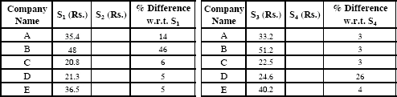
A person wishes to earn at least Rs.6000 in a day in minimum transactions with a minimum amount of investment. How can he fulfil his objective?
Investing in 1200 shares of company A in and sell all the shares in .
Investing Rs.17300 in the stock market in company D and sell all the shares in .
Investing in 300 shares of company B in and sell all the shares in .
All of these
What is the best deal out of the following transactions in terms of earning maximum profit?
Invest Rs.6000 in company A and use the price differential in stock exchanges and .
Invest in 300 shares of company B and use the price differential in and .
Invest Rs.30000 in company B and use the price differential in and .
Invest in 700 shares of company C and use the price differential in and .
A person decides to buy 600 shares of company E in . He then sells 300 shares in , 100 in and 200 in . What will be the profit/loss from the above transactions?
He would have a profit of Rs.270
He would have a loss of Rs.270
He would have a profit of Rs.340
He would have a loss of Rs.340
If the same person (as in above problem) gets a chance to convert his loss into a profit of at least Rs. 8500 by investing the same amount, what would be the best transaction for him?
Buy 453 shares of company B in and sell in .
Buy 1091 shares of company D in and sell 700 shares in while remaining 391 in .
Buy 656 shares of company A in and sell in .
None of the these
Directions for next nine questions: Each question is followed by two statements.
Is X = Y?
I.
II. X + Y = 0.
if the question can be answered by using any of the statements alone, but not by using the other statement alone.
if the question can be answered by using either of the statements alone.
if the question can be answered only by using both the statements together.
if the question cannot be answered.
If X 0 and – 4XY + Y = 0, what is the value of Z?
I. Z = 32X.
II. Z = 4Y.
if the question can be answered by using any of the statements alone, but not by using the other statement alone.
if the question can be answered by using either of the statements alone.
if the question can be answered only by using both the statements together.
if the question cannot be answered.
What is the average age of the students in a class?
I. Sum of the ages of the students and teacher is 210.
II. There are 20 students in the class.
if the question can be answered by using any of the statements alone, but not by using the other statement alone.
if the question can be answered by using either of the statements alone.
if the question can be answered only by using both the statements together.
if the question cannot be answered.
What is the percentage discount?
I. The customer get three successive discounts of 20%, 25%, and 10%.
II. The customer pays Rs.108 after the discounts for the actual cost of Rs.200.
if the question can be answered by using any of the statements alone, but not by using the other statement alone.
if the question can be answered by using either of the statements alone.
if the question can be answered only by using both the statements together.
if the question cannot be answered.
If P represents the principal, R the rate of interest and N the number of years, then find the simple interest.
I. N =
II. R × N =
if the question can be answered by using any of the statements alone, but not by using the other statement alone.
if the question can be answered by using either of the statements alone.
if the question can be answered only by using both the statements together.
if the question cannot be answered.
In 1997, ABC Corporation had sales of Rs.70000 and had a profit of Rs.3500. The Corporation profit in 2000 was what percent of its sales in 2000?
I. The difference between sales and profit in 2000 was 20% greater than the difference between sales and profit in 1997.
II. Sales and profit in 2000 each increased by 20% over sales and profit in 1997.
if the question can be answered by using any of the statements alone, but not by using the other statement alone.
if the question can be answered by using either of the statements alone.
if the question can be answered only by using both the statements together.
if the question cannot be answered.
If |x| > 2 and x is an integer, then what is the value of x?
I. x is a negative number
II. + x – 12 < 0
if the question can be answered by using any of the statements alone, but not by using the other statement alone.
if the question can be answered by using either of the statements alone.
if the question can be answered only by using both the statements together.
if the question cannot be answered.
What is the difference of the cubes of two numbers?
I. products of the numbers is 16.
II. difference of the numbers is 10.
if the question can be answered by using any of the statements alone, but not by using the other statement alone.
if the question can be answered by using either of the statements alone.
if the question can be answered only by using both the statements together.
if the question cannot be answered.
Match the name of the country with the name of the Parliament.
i] West Germany |  | a] Eirann
ii] Ireland |  | b] Seym
iii] Poland |  | c] Tshogdu
iv] Bhutan |  | d] Bundestag
 | i – b, ii – d, iii – a, iv – c
 | i – b, ii – a, iii – d, iv – c
 | i – d, ii – a, iii – b, iv – c
 | i – c, ii – d, iii – b, iv – a
Which of the following statement is false:
[i] A “call” option gives the buyer of the derivative the right but not the obligation to buy the underlying asset on or before a certain future date for a specified price whereas a “put” option gives the buyer of the derivative the right but not the obligation to sell the underlying asset on or before a certain future date for a specified price.
[ii] An “American Option” can be exercised only on the expiration date whereas an “European Option” can be exercised at any time upto the expiration date.
Only (i)
Only (ii)
Both of the above
None of the above
Which Indian company recently acquired a majority stake in Chennai based books and music retail chain “Landmark”.
Trent
Pantaloon Retail
Shopper’s Stop
Planet M
Ciprofloxacin is used to cure _____, if detected at an early stage.
Cancer
Anthrax
AIDS
Hepatitis B
In ancient India who was the founder of the Mauryan Empire?
Chandragupta
Asoka
Siddhartha Gautam
Akbar
The galaxy we live in is called the Milky Way. It is shaped approximately like:
A round ball
A doughnut
A pretzel
A flat spiral
Which Indian company has recently picked up a minority stake in Chennai based Celebrity Fashions Limited which markets the brand “Indian Terrain”.
Reliance Capital
Kotak Mahindra Bank
Provogue
Pantaloon Retail
Who would you associate with the book ‘By God’s Decree’?
Kiran Bedi
Kapil Dev
Lala Amarnath
Sunil Gavaskar
Which Indian newspaper publisher recently acquired “Odyssey India” which is a retail chain of book stores.
HT Media
Midday Multimedia
Deccan Chronicle Holdings
Bennet & Coleman
‘Circulation of blood’ was discovered by:
William Harvey
Max Planck
Mark Twain
Johann Gutenberg
What is special about Sirius, the Dog Star?
It is the only star first observed by Albert Einstein
It is the brightest star in the sky
It always lies directly above the North Pole
It emits staccato barking sounds which radio telescopes can detect
Durand Line is the International line between:
USA and Mexico
India and Pakistan
Pakistan and Afghanistan
India and China
In Indian Budget terminology which of the following come under “Non Plan Expenditure”.
Defence expenditure
Postal Deficit
Subsidies
All of the above
Which one of the following are not evenly matched.
Gujarat – Mount Abu
Himachal Pradesh – Dalhousie
Uttaranchal – Nainital
Kerala – Munnar
Which Indian Oil & Gas major recently announced two definite agreements signed between the Company and Mittal Investment Sarl, the investment holding arm of Mittal Steel, world’s largest Steel Company, to form two joint ventures?
I.O.C.L.
O.N.G.C.
O.I.L
G.A.I.L.
What does G.I. in G.I. Joe stand for?
Greenfield Incendiary
Government Issue
General Infantry
GenNext Incorporated
In Indian Budgetory terminology the deficit or difference between India’s exports and imports.
Plan Deficit
Balance of payments
Current Account Deficit
Fiscal Deficit
The Left Front in October 2005, signalled the launch of a nationwide agitation against the Congress-led UPA government’s stand on:
Iran in the International Atomic Energy Agency (IAEA) meeting in September, which marked a shift in Indian foreign policy.
misleading” the nation over Bihar assembly dissolution.
Joint Indo-Russian air exercises.
The Government’s decision to pay Rs. 1 lakh to all those people whose houses had been damaged completely.
With whose help did Robert Bunsen, a German chemist, discover the elements caesium and rubidium?
Michael Faraday
Gustav Kirchhoff
John Tyndall
Adolf Baeyer
Which company has recently signed a Memorandum of Understanding (MoU) to purchase the manufacturing facility of Torrent Gujarat Biotech Ltd located at Masar, Dist. Baroda, Gujarat. as an asset sale for Rs550mn in an all cash deal subject to both the parties receiving necessary approvals / consents under applicable laws?
Biocon
Sterling Biotech
Bharat Biotech
Dr Reddys Labs
If you were to take a lump of coal and squeeze for a long time at very high temperatures, you would end up with:
Graphite
Volcanic glass, also known as obsidian
A smaller lump of coal
A diamond
It is generally an alloy of iron and carbon, often with an admixture of other elements. Name the metal.
Steel
Aluminum
Graphite
Brass
n Indirect taxes, which of the following taxes is effected on goods imported into India to offset Excise Duty charged on similar goods manufactured locally?
Special Customs Duty
Special Additional Duty
Countervailing Duty
Cenvat
Name the novel written by P. H. Newby to be the first winner of the Booker Prize in 1969.
The Elected Member
Something to Answer For
Figures in a Landscape
The Public Image
As per regulations of SEBI mutual funds must distribute minimum of what percentage of their profits to investors?
25%
49%
75%
90%
Which is the latest car launched by Ford India?
Ford Ikon
Ford Fiesta
Ford Accord
Ford Escort
Who is the Managing director of TATA Steel?
B. Muthuraman
M. Damodaran
Narayan Murthy
Ram Naik
Who is the first Communist Speaker of the Lok Sabha?
Manohar Joshi
P.A. Sangma
Somnath Chatterjee
Shivraj. V. Patil
Which of the following book is not written by Salman Rushdie?
Shalimar the Clown
Grimus
East, West
None of these
Consider the following statements on British playwright and poet Harold Pinter, who won the 2005 Nobel Prize in literature.
1] Pinter has also written for the cinema, penning screenplays for “The French Lieutenant’s Woman”, “The Accident”, “The Servant’’ and “The Go-Between”.
2] In 2003, Pinter published a volume of anti-war poetry about the Iraq conflict, and in 2004 he joined a group of celebrity campaigners calling for Blair to be impeached.
Which of these statements are true?
Only [1]
Only [2]
Both of the above statements
Neither of the above statements
Whom did Roger Federer beat at the US Open Final for his third Grand Slam title of 2005:
Andre Agassi
Andy Roddick
Tim Henmann
Lleyton Hewitt
When sugar crystals are stirred into water the sugar appears to disappear. What has happened to it?
The sugar has disappeared and no longer exists
A chemical change has taken place between the sugar and the water
The crystals of sugar have broken apart and the sugar molecules are now intermixed with the water molecules.
The sugar has evaporated into steam.
The longest river in the world, the Nile, has a length of:
3450 miles (5520 km)
4180 miles (6690 km)
4480 miles (7168 km)
5515 miles (8824km)
Who is the Chairman of the US Federal Reserve?
Ben Bernanke
Paul Wolfowitz
Pascal Lamy
G. W. Bush
The chemical formula for common salt is NaCl. This formula represents the makeup of each molecule of salt. What chemical is described with the formula KCl?
Lead chloride
Potassium chloride
Phosphorus chloride
Hydrogen Chloride
In terms of Astronomy and Astrophysics, who or what is Sedna?
The goddess of Space in Greek Mythology
The tenth planet
The name of the spacecraft to be sent to the Oort’s cloud
The oldest planet discovered yet.
The sport in which Bhuwaneshwari Kumari has won the national title, a record number of sixteen times.
Weight lifting
Table tennis
Badminton
Squash
Which of the following does India not import?
Wheat
Oilseeds
Cotton
Sugar
Which country is the largest consumer of Gold in the world?
United States of America
United Kingdom
India
South Africa
What was included into the GATT in 2005?
Agriculture
Services
Intellectual property
Textiles and clothing
Directions for next four questions: Refer to data below and answer the questions that follow.
Six people are from different professions viz mechanic, line man, cashier, hunter, industrialist and wireman. They own six different electronic instruments viz moblie phones, communicator, Handycam, ipods, laptop and wristwatch and each lives in six different places viz. Latur, Indore, Howrah, Cochin, Wardha and Mumbai. No person has his profession, place of living and his electronic instrument starting with the same alphabet. The Mechanic, Hunter and Wireman carries a wrist watch, communicator and handycam respectively. The Lineman and Industrialist stay in Cochin and Wardha respectively. The Mechanic does not stay in Latur or Indore. Person having an Ipod stays in Latur and the Wireman does not stay in Mumbai.
What is the profession of a person staying in Mumbai.
Lineman
Cashier
Hunter
Industrialist
What is the profession of the person who owns an ipod?
Mechanic
Wireman
Hunter
Cashier
Where does the Wireman stay?
Indore
Mumbai
Latur
Cochin
Which electronic instrument does the person staying in Mumbai own?
Wristman
Communicator
Laptop
Handycam
Directions for next three questions: Refer to the data below and answer the questions that follow.
Anant has 3 children. One of them is Sagar. The family has five couples, seven males and seven females. Jaya is Sameera’s maternal aunt. Sagar has two sisters one of them is Jaya. Rohit is Sagar’s Brother-in-law and Sameera is his daughter. Anant has in all 5 grand children. Sagar and Jaya have 2 children each. Sonali is one of Jaya’s children. Sagar has 2 sons and only one of them is married.
If Shalaka is Sagar’s daughter-in-law, what is the relationship between her and Sameera?
Niece
Paternal aunt
Sister-in-law
Sisters
If Vijaya is Sameera’s mother, what is her relationship with Sonali?
Niece
Maternal aunt
Sister-in-law
Paternal aunt
If Geeta is Anant’s wife and Ramya is Sagar wife. How would Geeta be related to Ramya?
Daughter-in-law
Sister-in-law
Mother-in-law
Maternal aunt
Directions for next three questions: Refer to the data below and answer the questions that follow.
Nine friends go to a restaurant and are seated around a circular table. Mihir and Kusum have ordered for wafers; Kiran and Tulsi have ordered for Sandwiches; Bharat and Riya have ordered for Desserts and Ravi, Rima and Shyam have ordered for ice-cream. The people who have ordered the same eatable have to be seated together. If a person likes to have some other dish then he has to be seated besides the person who has ordered that dish. Kiran likes to eat wafers too, but he does not sit besides Mihir. Rima does not share her food with any one. Ravi wants to have a chat with Mihir so they sit together. Riya and Ravi would like to have a ice-cream. Kusum sits to the left of Mihir. Bharat likes to eat a Sandwich too.
Who sits beside Shyam?
Tulsi
Riya
Ravi
Mihir
Who sits between Kiran and Bharat?
Tulsi
Rima
Kusum
Riya
Who sits in between Mihir and Kiran?
Tulsi
Riya
Kusum
Either [1] and [3]
Directions for next five questions: Choose the option that best continues the series.
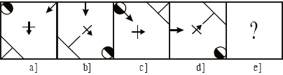
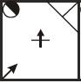
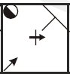
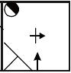
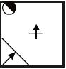
Choose the option that best continues the series.
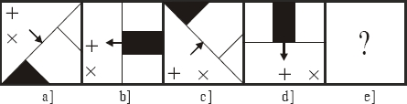
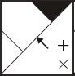
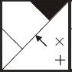
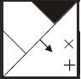
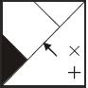
Choose the option that best continues the series.
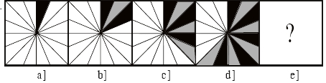
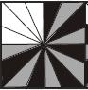
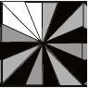
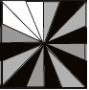
Choose the option that best continues the series.
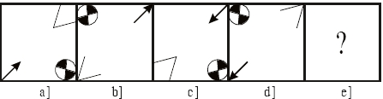
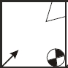
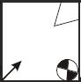
Choose the option that best continues the series.
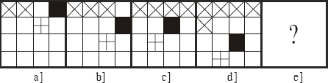
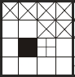
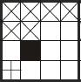
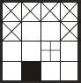
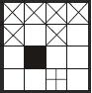
Directions for next two questions: Choose the correct alternative.
If WORK is coded as SCIG and PART is coded as ‘EYIM’ what is BLUE coded as?
WCOQ
WCQO
XBTW
BXWT
If DANGER is coded as GAAMII and FLAMES is coded as KWAYIK, how would VICTORIA be coded?
QQEMCQIA
QQEMCIQA
QQEMCIQA
QQEMCIAQ
Directions for next three questions: Refer to the data below and answer the questions that follow.
Seven chairs of seven different colours of a rainbow are arranged in a row in the order in which they appear in a rainbow. Starting from Violet from left to right. A person does not sit on the chair with the colour that he likes. Also a person can only sit on the chair adjacent to the chair whose colour he likes, this condition does not hold for Indu. A person also does not sit on the chair with colour starting with the first letter of his name, Vivek likes Indigo, Yogesh sits besides Geeta, Bhuvan likes Green, two males are seperated by a female, Rina like Red, Indu sits besides Vivek. Geeta, Indu and Rina are the only females and the remaining person is Onkar.
Who sits besides Vivek?
Indu and Rina
Rina and Geeta
Geeta and Indu
Cannot be determined
On which coloured chair does Indu sit on?
Yellow
Red
Blue
Green
Who is sitting besides Bhuvan?
Geeta and Indu
Indu and Rina
Rina and Geeta
Cannot be determined

